FACULTY EVALUATION
Programme Name: SBVP ALUMNI MASTERCLASS - GROW Module II Online Kenya (16th March 2026 - 20th March 2026)
Session: Reflections and Way Forward
Faculty Name: Dr. Nancy Nyambura Njiraini
No. of Respondents: 10
No. of Participants: 10
Evaluation Parameter | (%) Individual Score | (%) Programme Average
Punctuality (Commencement and Completion of Sessions) | 98 | 98
How well do you understand the core concepts presented? | 98 | 93
Rate your confidence in applying the new skills learnt | 93 | 88
Degree of Faculty preparedness for the sessions | 100 | 98
Content and methodology of the program | 98 | 96
Quality of class and group discussions | 98 | 93
The information presented in the course is relevant to my work (ministry) | 100 | 98
Average scores | 98 | 95

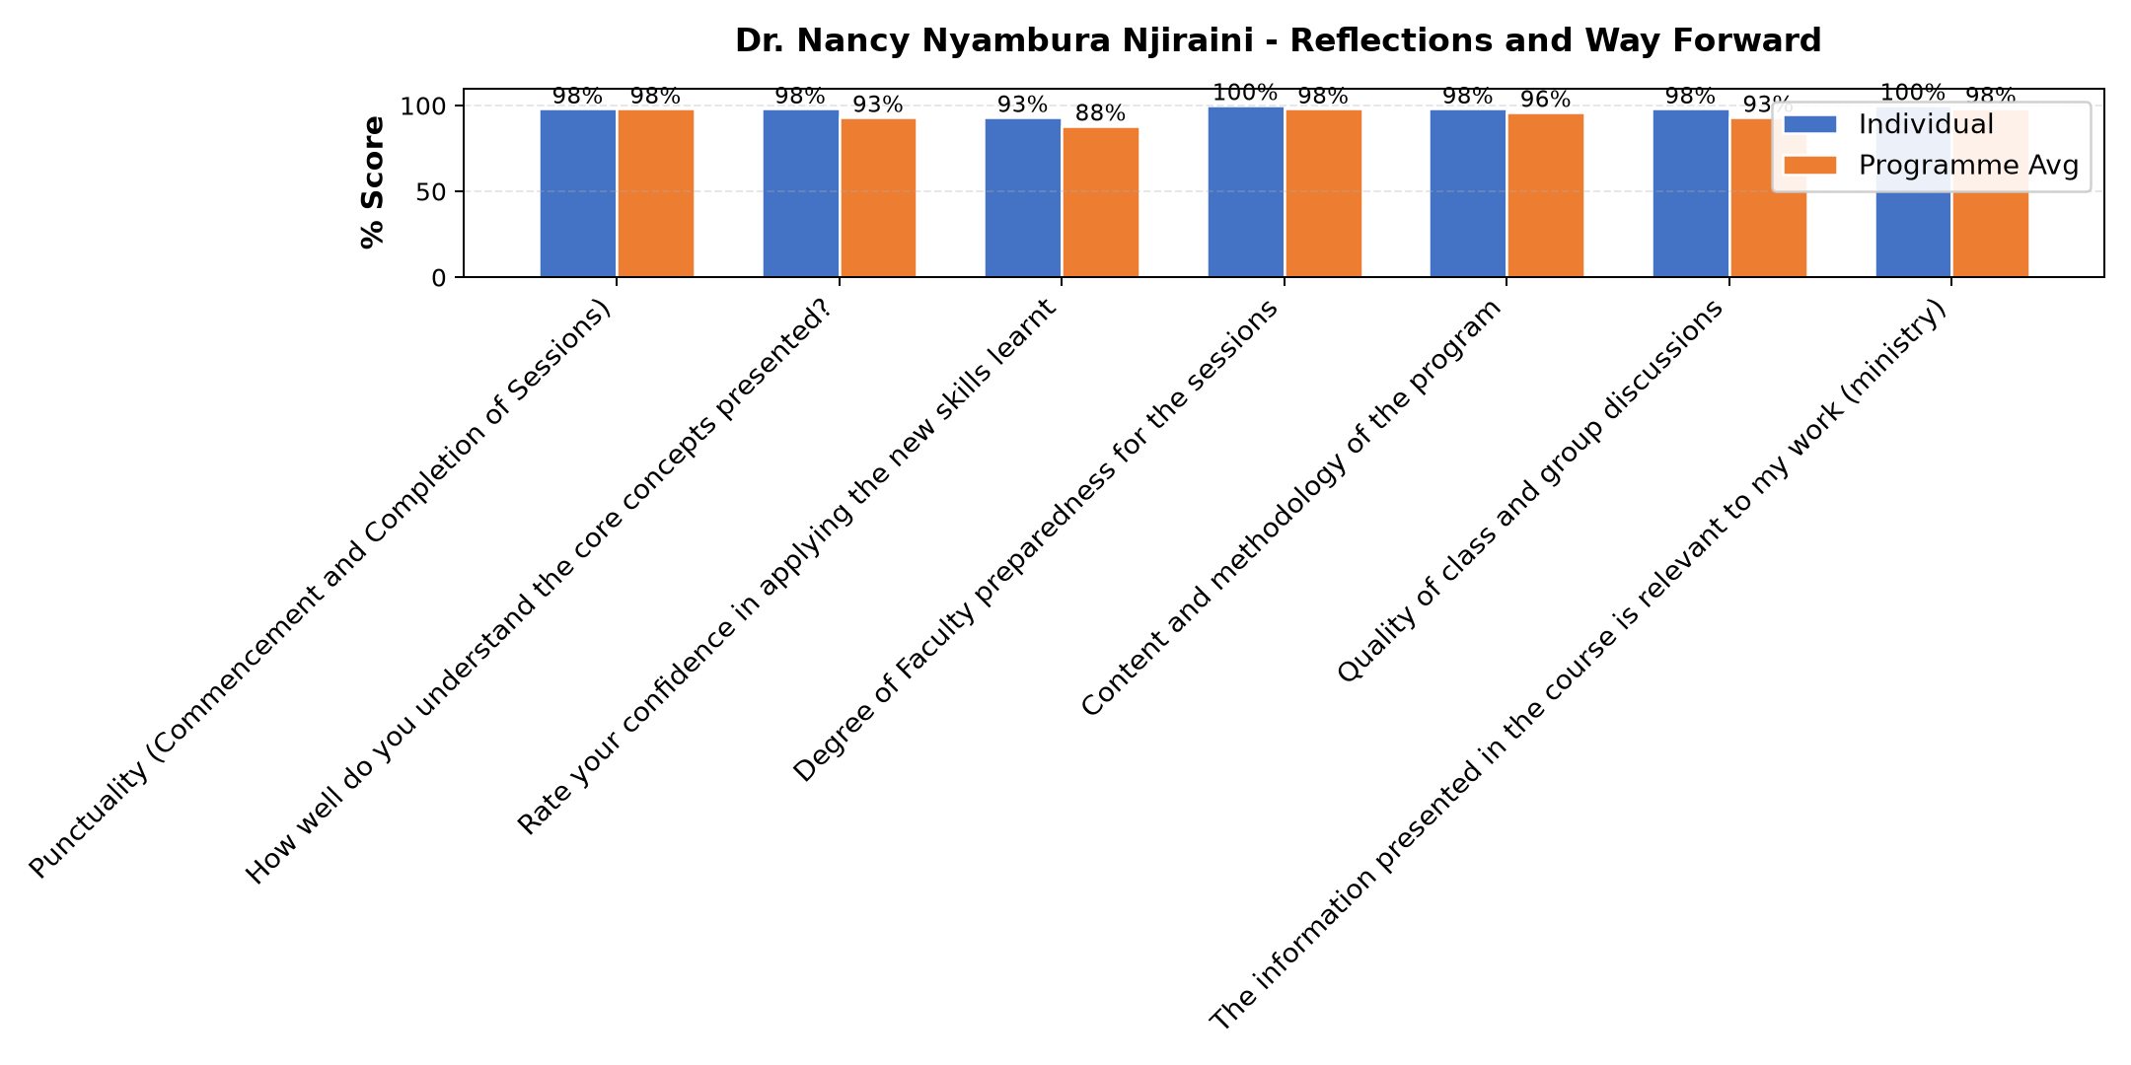

Comments & Feedback
- • Financial constraints
- • If am not able to recognize the challenges that the enterprise is facing so as to address them and go on.
- • Thank you the input is and will be of a great help
- • Lack of knowledge, skills and commitment.
- • Leadership and governance problem
- • If no total support from the my leadership.
- • Ridgity of leaders to accept the suggestion s
- • Ignorance. All was well elaborated
- • Any unexpected changes in the project administration, otherwise we are committed to support implementation through the application of all learnt knowledge.
SUBMITTED THROUGH:
SBS Evaluation Automation System

